**Restore Vertical Volume Display Bar in Windows 10 using Registry Editor**

1. Locate the Registry Editor by typing “regedit” into the Windows search bar. Either hit the enter key or click **Open** to launch it:

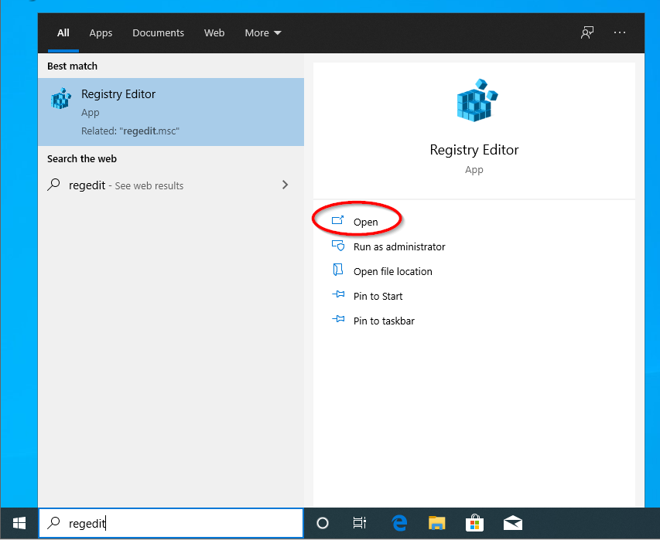

1. Click **Yes** when prompted by the User Account Control pop-up:

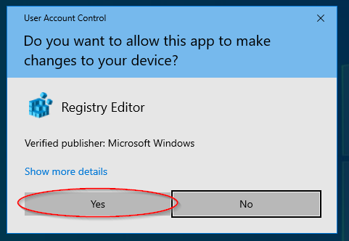

1. Double-click on the folder named **HKEY_LOCAL_MACHINE:**

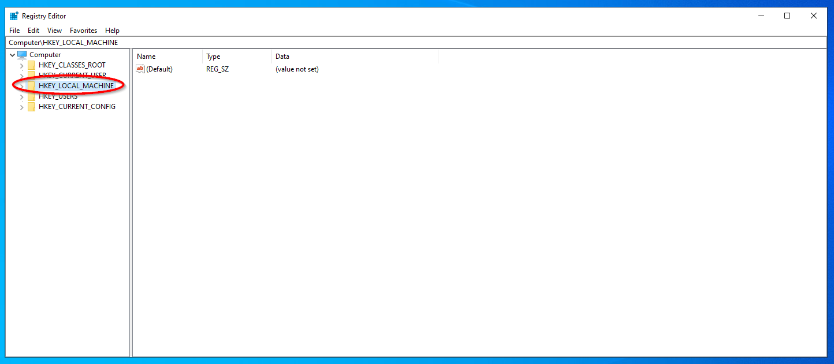

1. From inside this folder, we are going to open (double-click) on three more folders, until we reach the followed named “CurrentVersion”:

**Software** 🡪 **Microsoft** 🡪 **Windows NT** 🡪 **CurrentVersion**

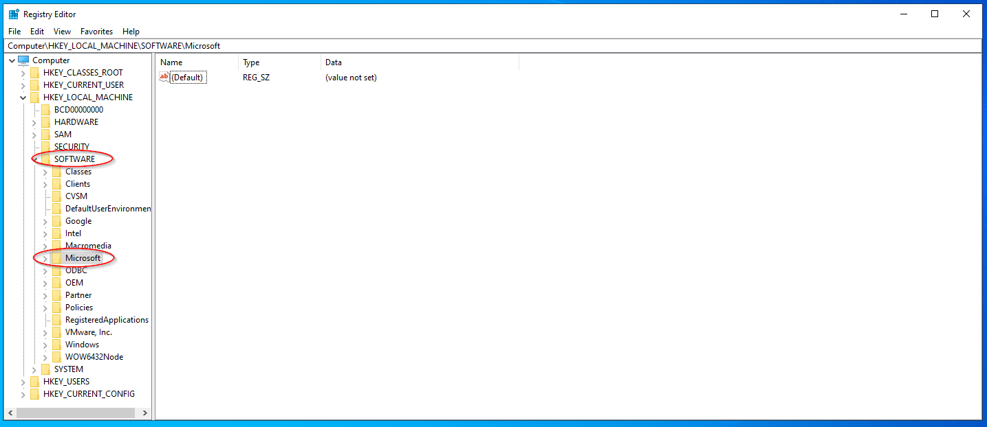

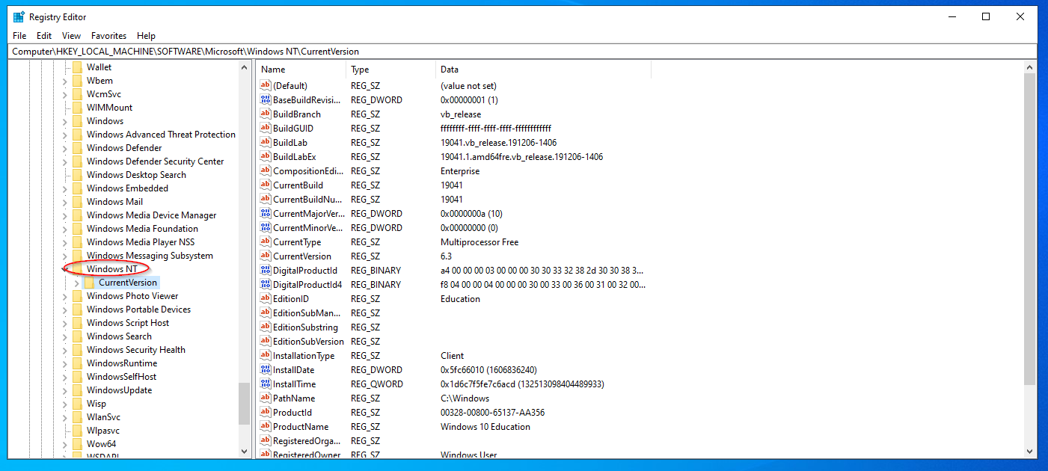

1. Once you reach **CurrentVersion**, you are going to right-click on it and select **New**, followed by **Key**:

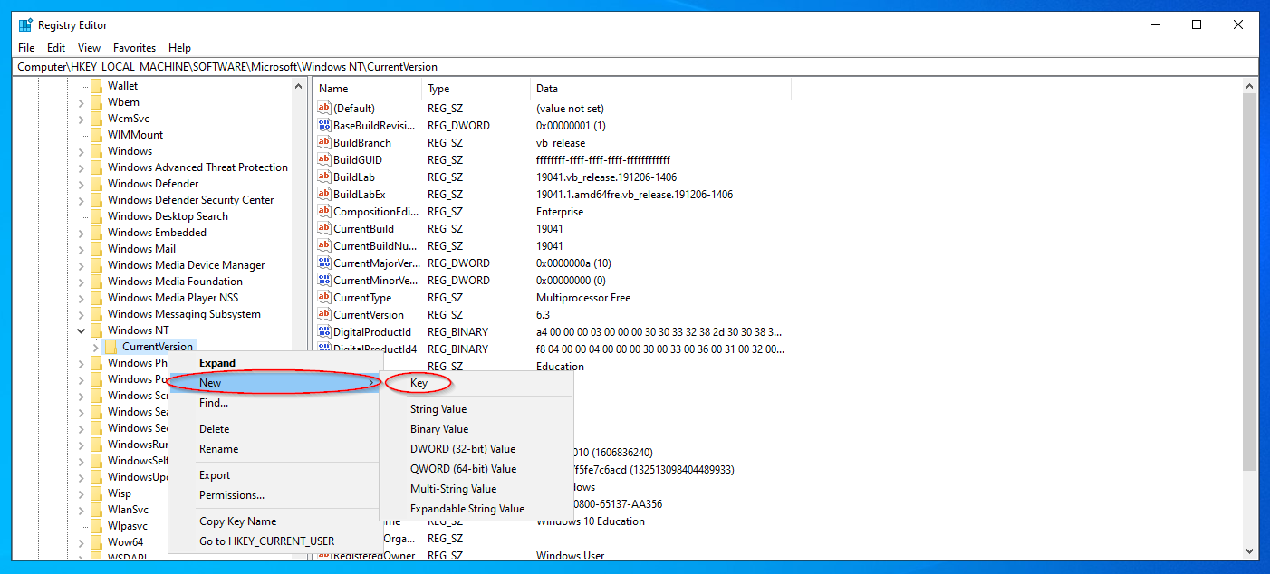

1. Name this new key (folder) **MTCUVC** then hit the enter key:

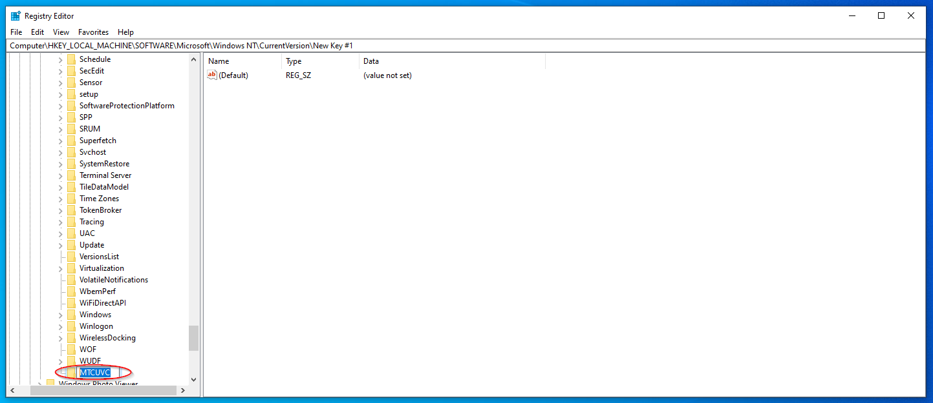

1. Double-click the new **MTCUVC** key to select it. Right-click anywhere within the blank space to the right-hand side of the window. Select **New**, then click

**DWORD (32-bit) Value:**

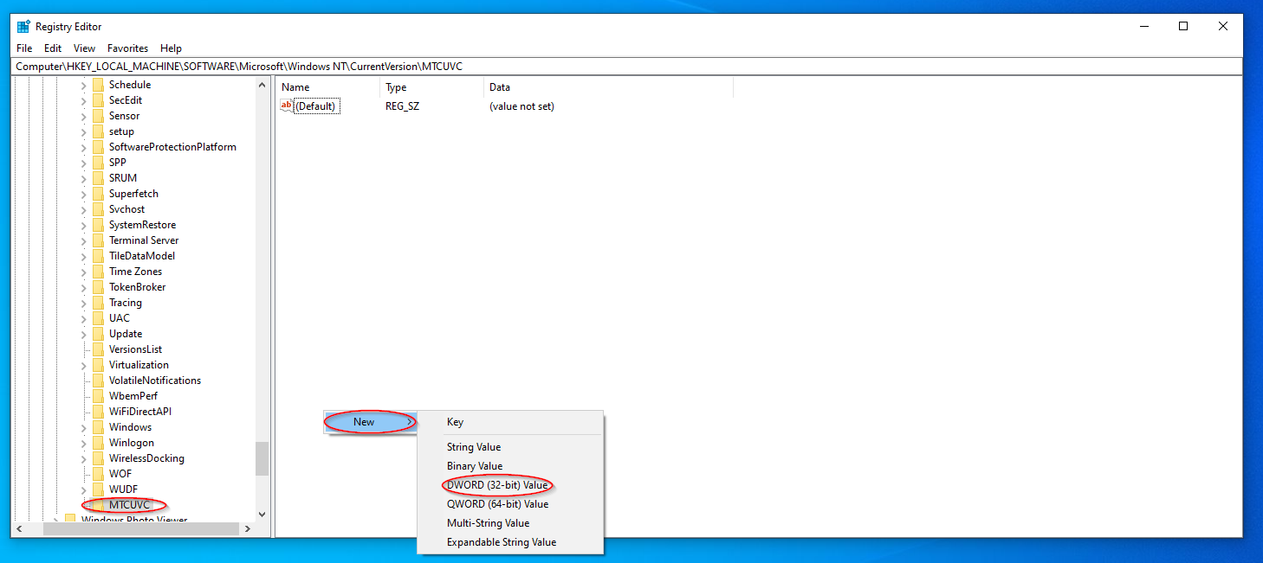

1. Rename this new DWORD value **EnableMtcUvc** then hit the enter key:

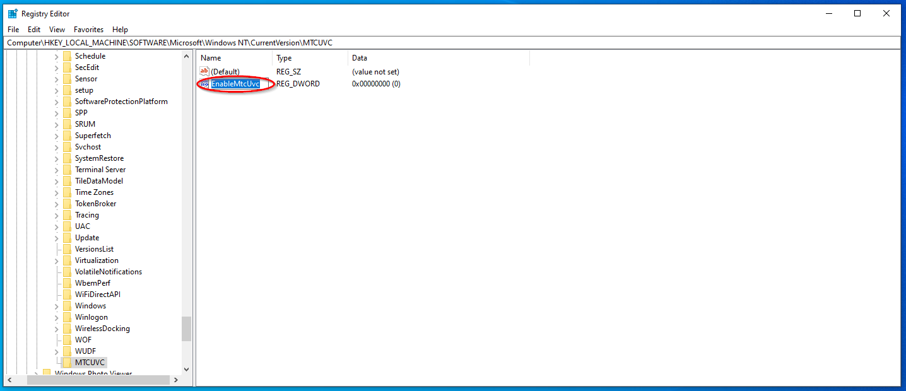

1. Double-click the newly renamed **EnableMtcUvc** value and ensure its “Value data” field is set to **0**, then click **OK**:

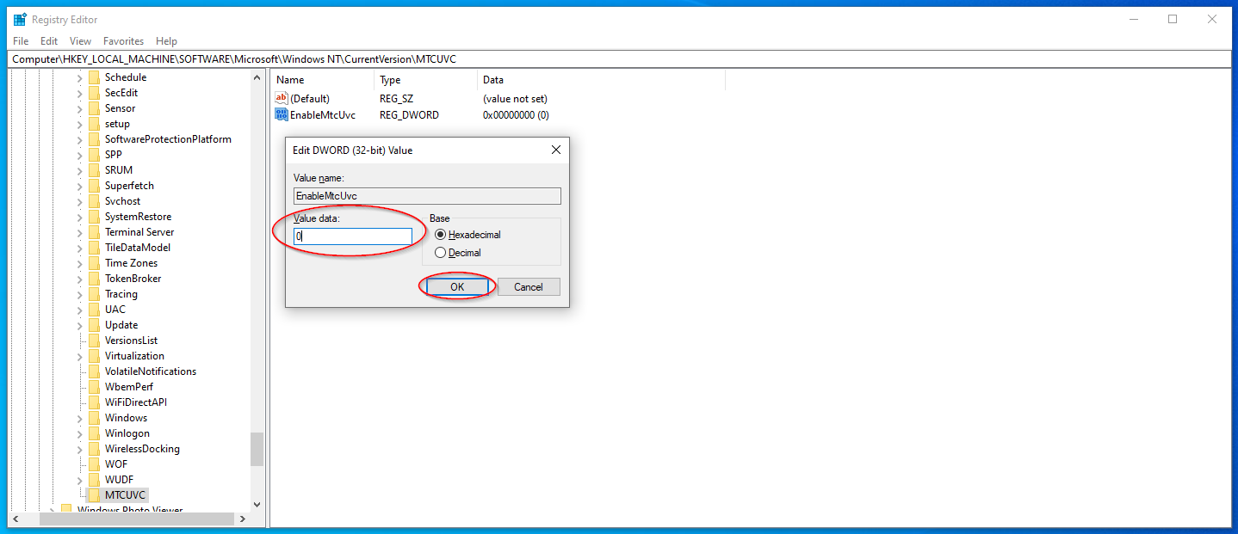

1. Close the Registry Editor and restart the device to apply the changes.
2. Click the speaker icon in the bottom-right corner of the screen and confirm the volume control display has been set to the vertical display:

